- Large regulated price increases, higher oil prices, weaker sterling, and the impact of policy measures from October's Budget will combine to cause an inflationary surge this year. We now expect CPI inflation to average 3.2% in 2025. But most of these pressures should prove temporary and we expect inflation to drop back close to the 2% target by the end of next year.
- Ofgem's energy price cap will rise by 6.4% from April, and gas prices are likely to remain elevated through much of this year. Meanwhile, the sterling oil price has leapt almost 7% since October, and our commodities team sees oil prices staying close to current levels. We expect the drag of 1ppt on CPI inflation from these two categories last year to almost disappear entirely in 2025.
- Weaker sterling will push up the prices of imported goods, particularly in import-intensive inflation categories like food and core goods. We also expect firms to pass on some of the rise in labour costs caused by increases in employers' national insurance contributions and the national living wage announced in October's Budget, which is likely to slow the fallback in services inflation this year.
- The upward pressures on inflation largely come from external sources and appear transitory. We think they are unlikely to result in significant indirect or second-round effects. The Monetary Policy Committee's latest inflation forecast appears consistent with this narrative. But if the MPC begins to see evidence that high inflation will persist, it will likely cut rates by less than the 75bps of cuts we forecast for the rest of this year.
Following a lengthy period of high inflation, falling goods prices dragged headline inflation back to the Bank of England's 2% target during summer and early autumn 2024. But developments since then have shifted the outlook. We expect CPI inflation will briefly hit 3.6% later this year and remain well above the BoE's target until late-2026 (Chart 1). Whether the Monetary Policy Committee views this as a temporary phenomenon will dictate the pace of rate cuts this year.
Chart 1: Similar to the BoE's latest forecast, we think inflation will be well above target this year
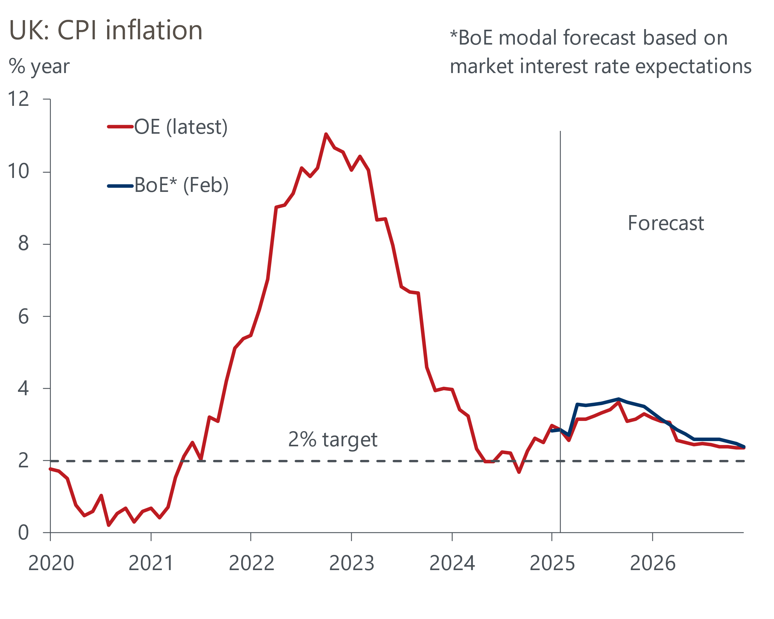
Source: Oxford Economics, Haver Analytics, Bank of England

Rising regulated prices will be the primary driver of higher inflation this year
Four factors are likely to push up inflation this year. The first and most significant is a sharp acceleration in regulated prices. Water bills are set to rise by an average 26% from April, which will contribute to a larger positive contribution from the core goods category this year. Meanwhile, the surge in European wholesale gas futures prices in December and January means the energy category will push up inflation in the spring.
After two warmer-than-usual winters, European temperatures in December 2024 and January 2025 were much closer to historical averages, which increased gas consumption. Meanwhile, the expiration of the five-year pipeline agreement between Ukraine and Russia on January 1 has resulted in the loss of around 5% of Europe's total gas imports. With little spare capacity at the other pipelines, this constrained supply and pushed up wholesale gas futures prices around the turn of the year. Given this increase, Ofgem has announced that the energy price cap will rise by 6.4% in April (Chart 2). This will see the contribution to CPI inflation from the energy category rise to 0.3ppts in April, from a drag of 0.4ppts in Q1 2025.
Chart 2: The surge in gas futures prices and base effects will push energy inflation up in April and July
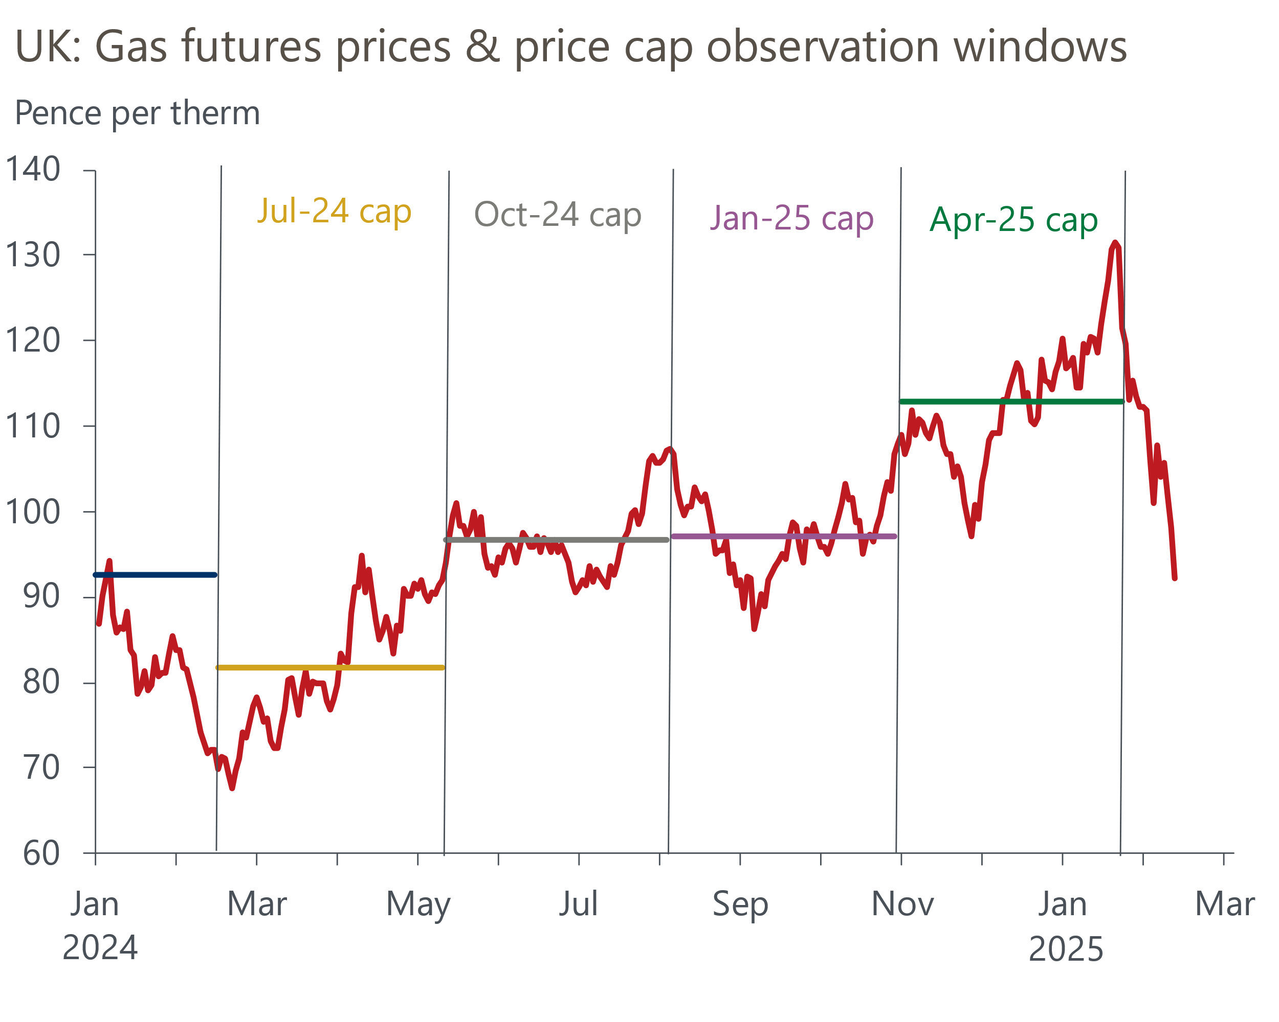
Source: Oxford Economics, Haver Analytics
Over the rest of this year, our commodities team expects prices to remain well above the levels seen in the middle of 2024. This partially reflects strong gas withdrawals from storage and the requirement for storage operators to refill before next winter. But also that it will be difficult to replace Ukraine's gas transit with alternative sources, and our scepticism that negotiations for an end to the Russia-Ukraine war will result in a quick resumption of pipeline gas flows from Russia to Europe. Therefore, we expect base effects in energy prices will come into play in July, which should push CPI inflation higher still before the contribution from the energy category starts to cool from October 2025 onwards.

Dollar strength will push up imported goods prices
The second factor is the impact of a slightly stronger US dollar on UK goods prices. The dollar appreciated against most major currencies in Q4 2024, including sterling, reflecting changes in US trade policy, the country's strong economic performance, and an increasingly hawkish Federal Reserve. This came after a brief period of unusual strength for sterling, and most of the depreciation in Q4 has since unwound. However, we expect the dollar to strengthen against sterling as we move through 2025, with the Federal Reserve likely to loosen policy only very modestly this year.
Exchange rate depreciations affect inflation via two main channels. First, imports of final goods become more expensive in domestic currency terms. Second, the cost of domestically produced goods and services rise as the price of imported inputs, such as raw materials, increases.
We expect the impact of a weaker sterling relative to the dollar will be felt most prominently in categories that are relatively more import-intensive, such as food and core goods. Our modelling also suggests that the passthrough of weaker sterling is likely to be gradual. In a stylised scenario where sterling depreciates against the dollar by the same magnitude as that seen in Q4 2024 with no subsequent unwinding, we find that the peak impact on inflation is seen one year later before slowly fading (Chart 3).
Chart 3: Our modelling suggests FX passthrough to inflation is gradual
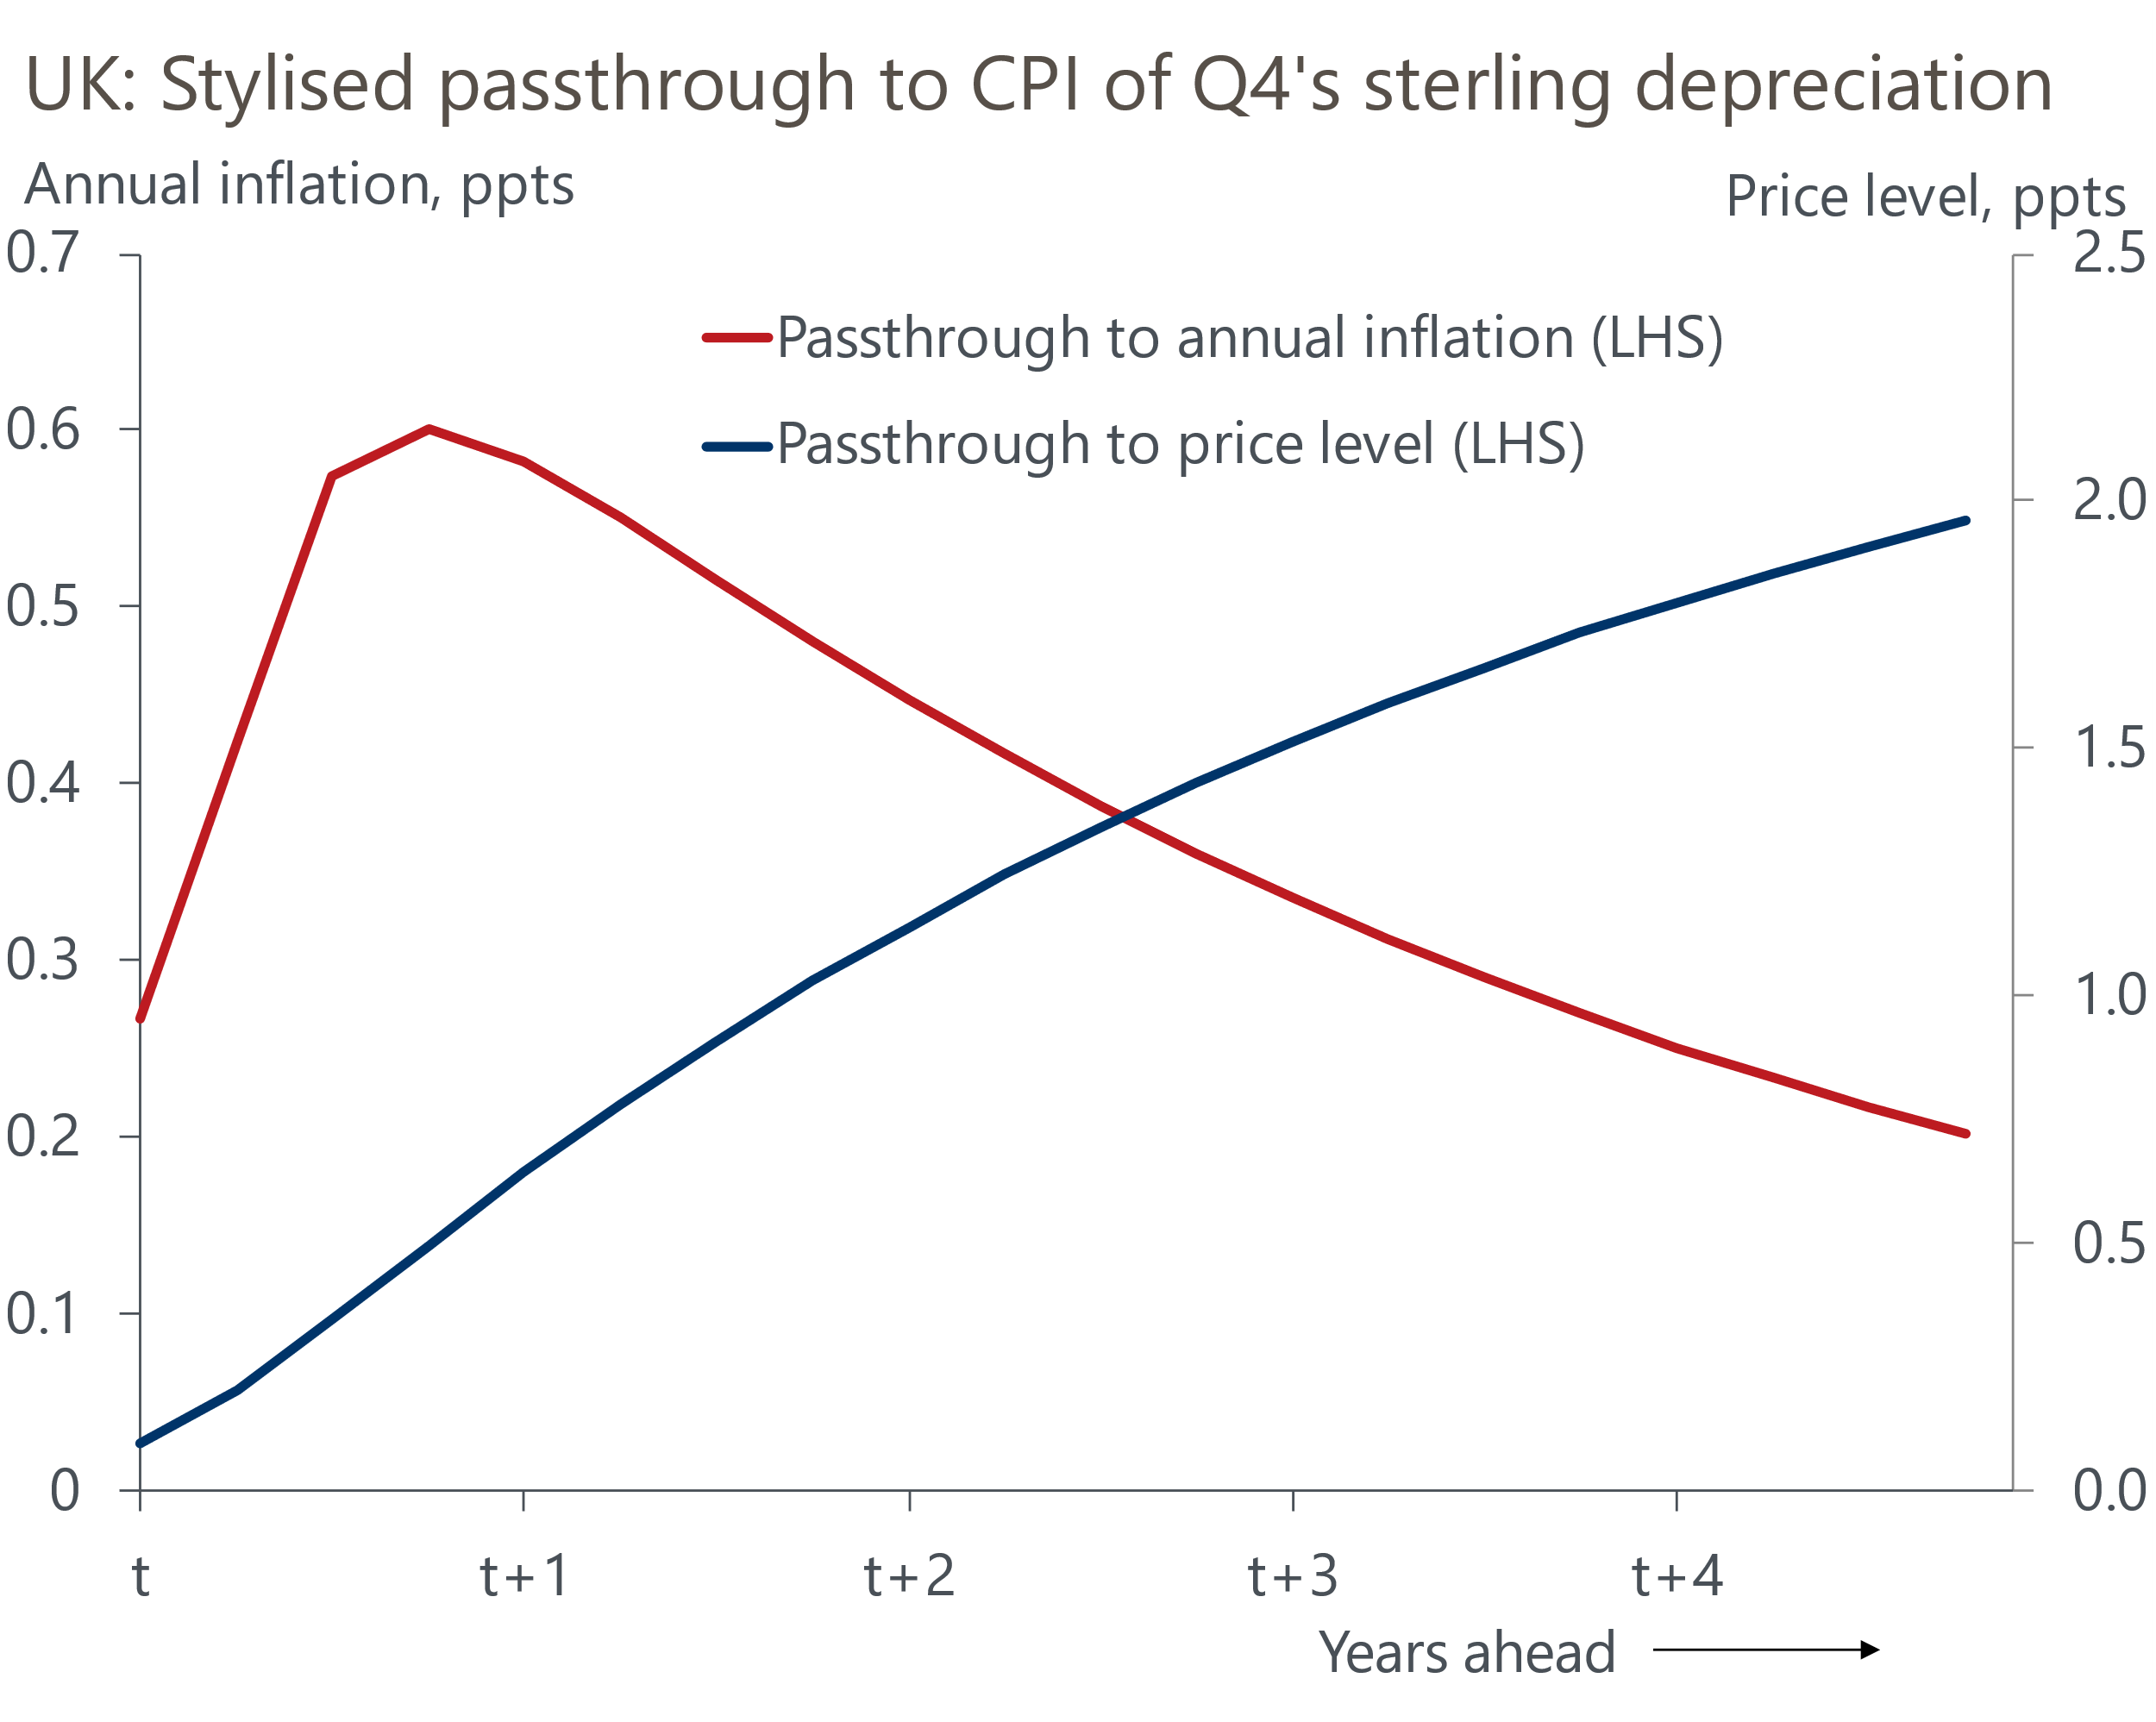
Source: Oxford Economics
Our baseline forecast assumes that President Donald Trump will not impose new across-the-board tariffs on US imports from the UK. This is based on our view that Trump is unlikely to view the UK as a priority for increasing tariffs given the US has a goods trades surplus with the UK, the UK imposes relatively low tariffs on imports from the US, and those tariffs have a minimal impact on US jobs. But even if the US did impose new tariffs on imports from the UK, we think this would have a very limited impact on UK CPI inflation, particularly if the UK decides not to retaliate.

The drag from petrol prices should disappear from October
The third reason we think inflation will rise markedly this year is higher oil prices. Although shifts in oil prices in recent months have been smaller than those seen in gas, Brent Crude has still risen by almost 7% on a sterling-adjusted basis since October (Chart 4). Our commodities team largely attributes this to the additional sanctions placed on Russia's oil industry by the outgoing Biden administration. Despite the upward pressure this has had on Brent Crude prices, the substantial tax wedge has meant that the increase in UK pump prices has been more modest. Still, motorists have seen unleaded prices rise by 4% since October, while diesel prices have leapt almost 6% over the same period.
Chart 4: Pump prices have risen sharply in recent months
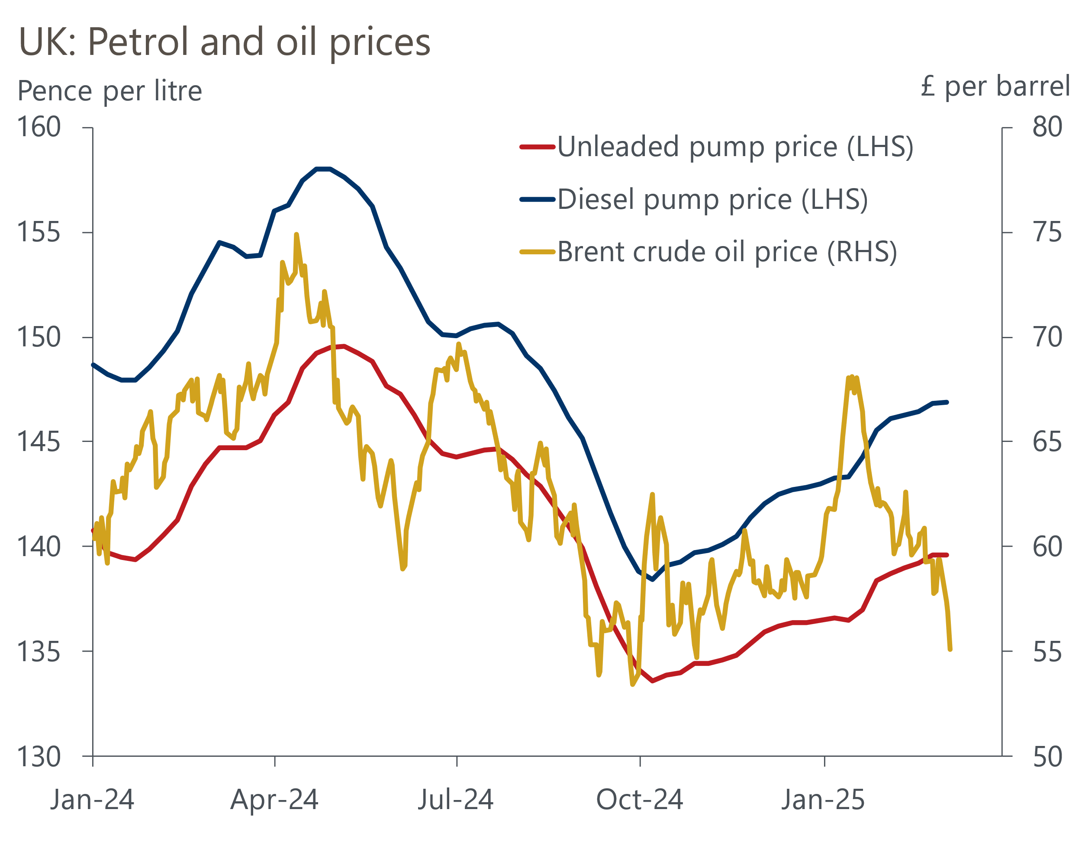
Source: Haver Analytics
Our commodities team expects the price of Brent Crude to remain close to current levels throughout 2025. Therefore, base effects mean the drag from the petrol category should shrink as we move through this year and disappear entirely from the autumn.

Policies announced in October's Budget will add to the inflationary pressure
The fourth and final reason why we think inflation will be well above target this year is due to the impact of government policies announced at October's Budget. The Chancellor's imposition of VAT on private school fees from January caused a 12.7% rise in private education prices that month, which contributed to a near 0.1ppt uplift in headline inflation. Looking ahead, the rate of employers' national insurance contributions will rise to 15% from 13.8% from April. The point at which firms start paying the tax will fall to £5,000 a year, from £9,100 a year now. The national living wage will also increase in April, rising by 6.7% to £12.21 per hour.
How firms choose to respond to this year's large rise in labour costs will have significant implications for inflation. Since the NICs increase was announced, the BoE has asked firms responding to its Decision Maker Panel how they plan to react. More than half expect to lower margins, raise prices, and reduce headcount, while nearly 40% are expecting to offer smaller pay rises (Chart 5).
Chart 5: More firms expect to hike prices because of the rise in NICs than reduce headcount or cut pay
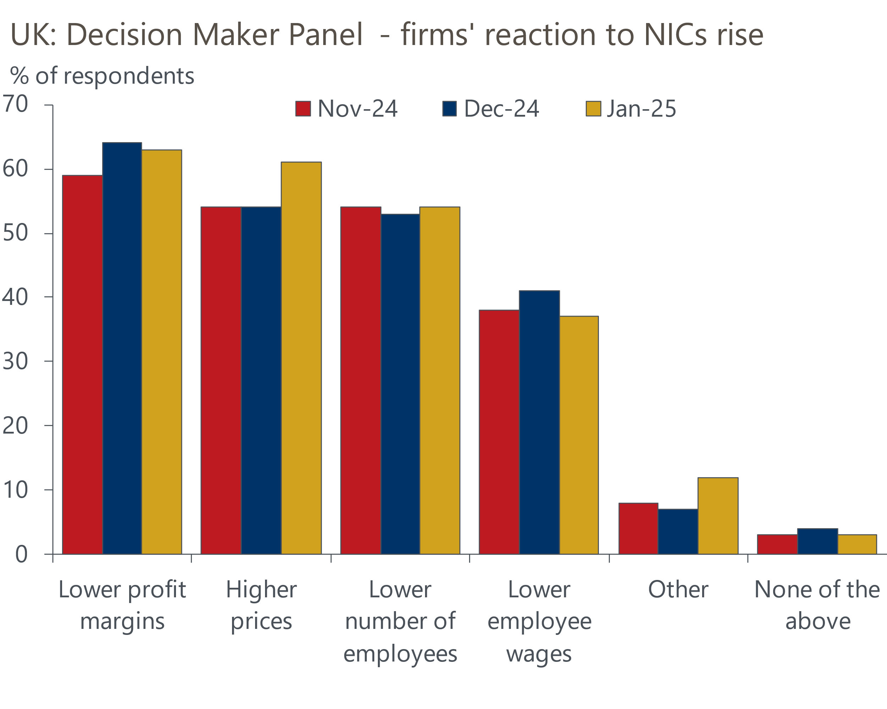
Source: Bank of England Decision Maker Panel
What surveys don't tell us is the likely magnitude of price rises. With demand relatively weak across the economy, this will limit the ability of firms to raise prices much in response to the large increase in labour costs. But on the flip side, corporate profitability is at a 23-year low following several years of sharply rising non-labour costs, with energy and debt servicing costs particularly important. Therefore, the ability of firms to keep absorbing large cost increases will be limited.
We think firms will only pass on some of the rise in labour costs to consumers, but given the services sector is relatively more labour-intensive, the passthrough to services prices is likely to be strong. Excluding indexed and volatile components, underlying services inflation has cooled steadily over the past two years. However, with the impact of recent fiscal policy changes coming on top of the ongoing second-round effects from elevated wage growth, we think services inflation is likely to prove relatively sticky this year and decline only gradually.

We expect CPI inflation to hit 3.8% in September
Headline inflation is likely to dip over the next couple of months before a renewed pickup from April. This is when increases in regulated prices will take effect, resulting in a larger positive contribution from the core goods category and the drag from the energy category disappearing entirely. We then expect inflationary pressures to build through the summer. And though services inflation is likely to soften, it is unlikely to do so fast enough to offset the upward pressures from elsewhere. So, we expect headline inflation to briefly hit a peak of 3.6% in September.
But most of this year's upward pressures are likely to prove temporary. The support from the energy category should start to fade from October as base effects come into play. The gradual normalisation of price setting for food and core goods should see the positive contribution from these components slowly decline. Moreover, the scale of increases in energy prices this year is unlikely to generate strong indirect effects on non-energy-related goods and services. And in a similar vein, we think firms will lower headcount and pay settlements in response to higher labour costs, which should reduce the second-round effects of strong pay growth on services inflation. As a result, we expect headline inflation to gradually drift down through the end of this year and next, to finish 2026 only slightly above the BoE's 2% target (Chart 6).
Chart 6: CPI inflation is expected to peak at 3.6% in September before returning close to target by end-2026
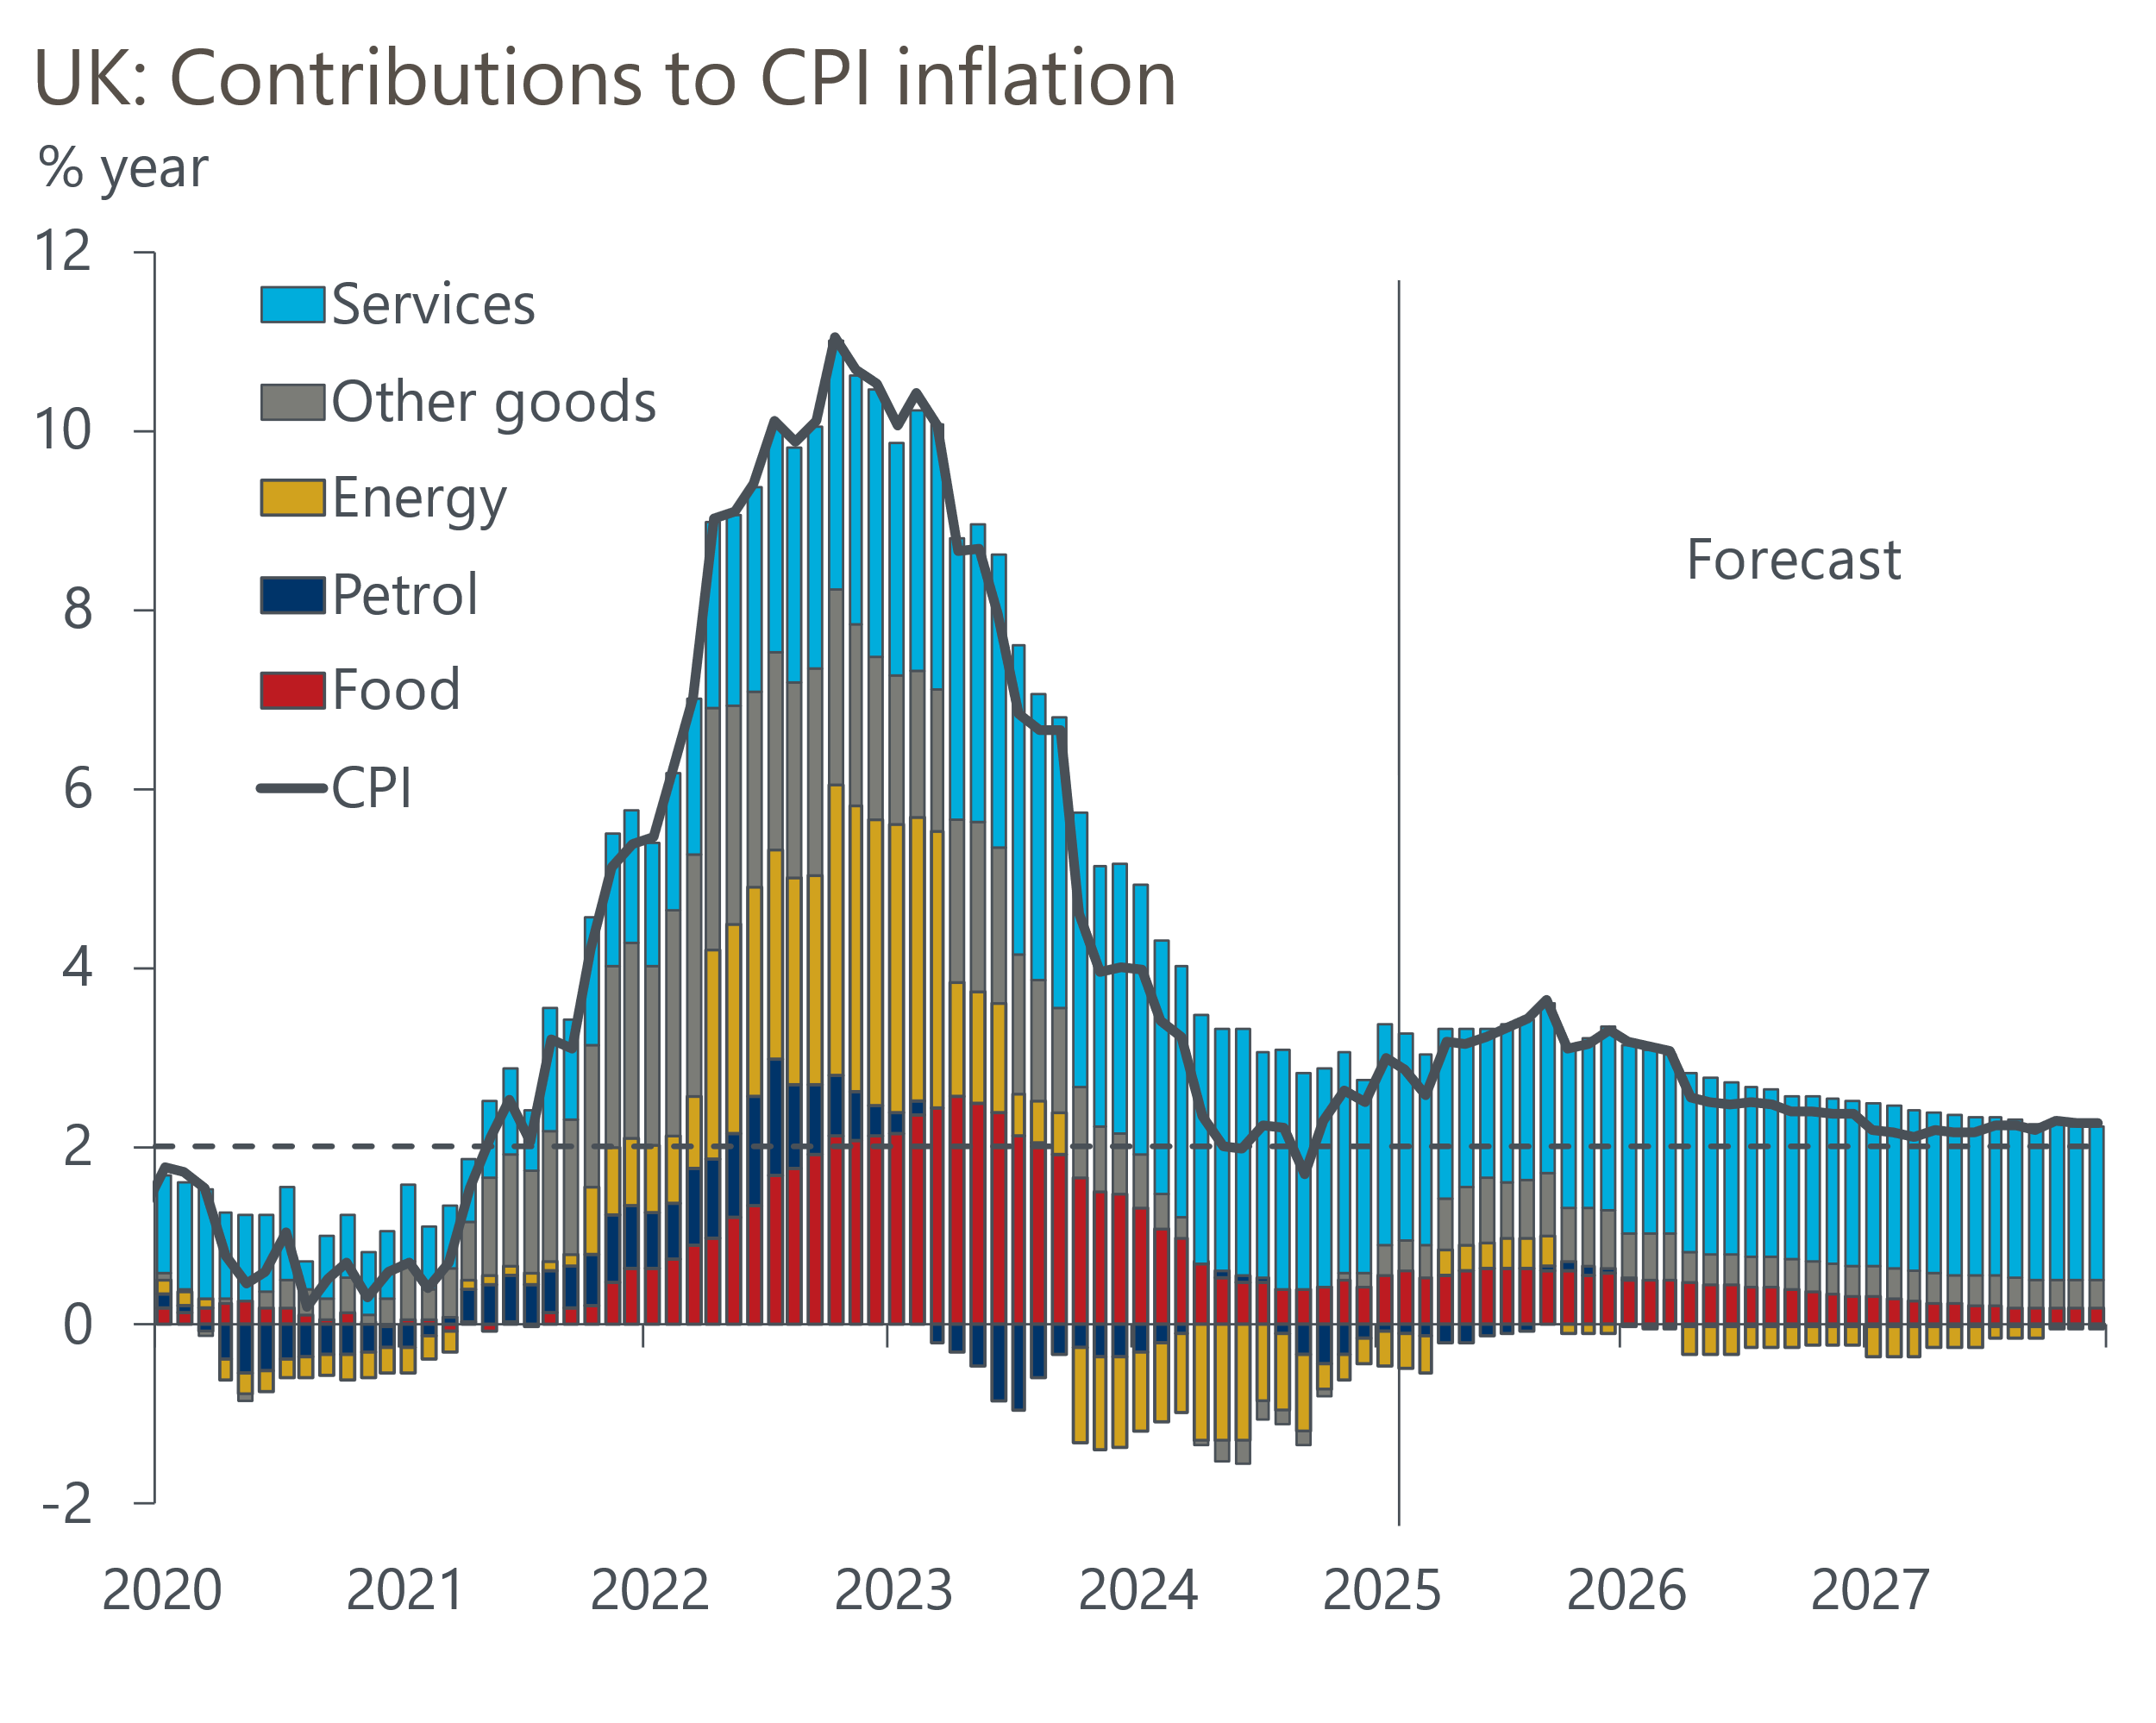
Source: Oxford Economics, Haver Analytics

Rising inflation won't prevent the MPC from cutting, but it could influence the pace of cuts
Our expectation is that the factors driving CPI inflation higher this year largely come from external forces and are likely to fade in the medium term – the relevant time horizon for monetary policy. Therefore, we maintain our long-held view that the MPC is likely to stick to its quarterly pace of rate cuts. Our forecast sees three further 25bps cuts this year in May, August, and November, which would leave Bank Rate at 3.75% by the end of 2025.
The BoE's latest inflation forecast shows headline inflation peaking later this year before returning close to the 2% target by the end of 2026. It therefore appears broadly consistent with our view that the pressures pushing inflation upwards this year will prove temporary.
How the MPC interprets incoming inflation and labour market data will be key to whether the committee deviates from its established 'cut-hold' approach to loosening policy. On one hand, evidence of much weaker output and employment growth could yield a slightly more aggressive pace of rate cuts. But on the other, the MPC is becoming increasingly concerned about weak supply and how this is manifesting itself in sticky pay growth. Therefore, the committee is likely to view stronger-than-expected pay outturns as being indicative of underlying price pressures persisting, and would probably respond by cutting rates by less than the 75bps of cuts we forecast for the rest of this year.

